Day 2

Set 1:E-Commerce catalogue and Traffic Analysis

Qn1:Graph and traversal techniques
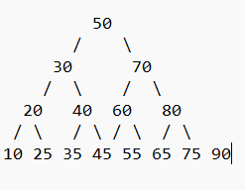
INORDER:
INORDER(root):
IF root is NULL:
RETURN
INORDER(root.left)
PRINT root.data
INORDER(root.right)

POSTORDER:
POSTORDER(root):
IF root is NULL:
RETURN
POSTORDER(root.left)
POSTORDER(root.right)
PRINT root.data

PREORDER:
PREORDER(root):
IF root is NULL:
RETURN
PRINT root.data
PREORDER(root.left)
PREORDER(root.right)

Qn2: – Hashing and HashMaps

SKUs = [101, 102, 103, 104, 105, 106, 107, 108]
Hashing Functions: h(value)=value%5
For example:
105%1=1 and 106%5=1
Here the place where collision occurs.

Linear chaining helps to avoid the collision
Index 0: [105]
Index 1: [101, 106]
Index 2: [102, 107]
Index 3: [103, 108]
Index 4: [104]

Qn3: Cycle Detection in an Undirected E-Commerce Graph

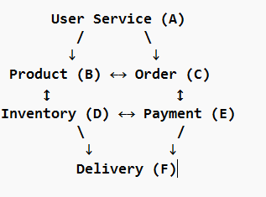
BFS: A B C D E F
DFS: A B C E D F

Pseudocode:
CYCLE_DETECTION(graph):
Create an empty visited set
FOR each node in graph:
IF node is not visited:
IF DFS(node, NULL) is TRUE:
RETURN TRUE
RETURN FALSE
DFS(node, parent):
Mark node as visited
FOR each neighbour of node:
IF neighbour is not visited:
IF DFS(neighbour, node) is TRUE:
RETURN TRUE
ELSE IF neighbour is not equal to parent:
RETURN TRUE
RETURN FALSE
MAIN:
IF CYCLE_DETECTION(graph) is TRUE:
PRINT "Cycle Detected"
ELSE:
PRINT "No Cycle"

QN4: Sliding Window: E-Commerce Traffic Analysis

Find the busiest continuous 3-hour window (the 3 consecutive hours with the highest total number of visitors).

visitors = [10, 20, 30, 40, 50, 60, 70]

Pseudocode:
FIND_MAX_VISITORS(visitors, k):
window_sum = SUM of first k elements
max_sum = window_sum
FOR i = k TO length(visitors) - 1:
window_sum = window_sum - visitors[i-k]
window_sum = window_sum + visitors[i]
max_sum = MAX(max_sum, window_sum)
PRINT max_sum

Output:
Maximum visitors: 180

Qn5: Two Pointers: E-Commerce Gift Card Pair

Our task is to find all pairs of products whose combined price equals the gift card value.

Sample Input:
prices = [10, 20, 30, 40, 50, 60, 70, 80]
target = 100

Pseudocode:
FIND_PAIRS(prices, target):
SORT prices
left = 0
right = length(prices) - 1
WHILE left < right:
sum = prices[left] + prices[right]
IF sum == target:
PRINT prices[left], prices[right]
left = left + 1
right = right – 1
ELSE IF sum < target:
left = left + 1
ELSE:
right = right – 1

Output:
20 80
30 70
40 60

